**Citizenship, Economics and Society**

**(Secondary 1-3)**

**Support Resources**

**Secondary 1**

**Module 1.1**

**Self-understanding and Life Skills**

**Part 5:**

**Life Planning**

(Self-learning materials included)

Personal, Social and Humanities Education Section

Curriculum Development Institute

Education Bureau

**Introduction**

* The “Citizenship, Economics and Society (Secondary1-3) Support Resources” covers the essential learning contents of Strands 1, 5 and 6 in the Personal, Social and Humanities Education Key Learning Area. It is designed to support the implementation of the Citizenship, Economics and Society curriculum.
* The support resources provide diversified learning activities to help students acquire knowledge and understand concepts, develop skills and nurture positive values and attitudes. In addition, they offer teaching guidelines and suggestions on learning and teaching activities for teachers’ reference. Further, they provide reading materials to enhance students’ interest in reading.
* “Module 1.1 Self-understanding and Life Skills Part 5: Life Planning” for Secondary 1 was developed by the School of Education and Languages of the Open University of Hong Kong, commissioned by the Personal, Social and Humanities Education Section, Curriculum Development Institute of the Education Bureau.

**Module 1.1 Self-understanding and Life Skills**

**Part 5: Life Planning**

**Contents**

|  |  |
| --- | --- |
| **Teaching Design** | **Pages** |
| Lesson 1 and Lesson 2: Personal interests and talents and opportunities and challenges around us | 4 |
| Lesson 3: Setting life goals | 7 |
|  |  |
| **Learning and Teaching Activities** |  |
| Worksheet 1: Life planning | 11 |
| Worksheet 2: Self-awareness: Understand yourself | 13 |
| Worksheet 3: Awareness of the surroundings: Explore the external environment | 17 |
| Worksheet 4: Setting goals | 25 |
| Worksheet 5: Principles of setting goals | 28 |
| Worksheet 6: Taking action to equip yourself | 34 |
|  |  |
| **Joyful Reading** |  |
| Guess who I am | 37 |
|  |  |
| **Self-learning Materials** |  |
| Take action on our dreams! | 40 |
|  |  |
| **References** | 44 |

**Teaching Design:**

|  |  |  |  |
| --- | --- | --- | --- |
| **Topic:** | Life Planning | | |
| **Duration:** | 3 lessons | | |
| **Learning Objectives:** | * To understand personal interests and talents * To be aware of opportunities and challenges around us * To set short-term and long-term goals | | |
| **Lesson 1 and Lesson 2 (Personal interests and talents and opportunities and challenges around us)** | | | |
| **Pre-lesson Preparation:** | Students shall finish the following before class:   * Read Worksheets 1-3 and complete relevant activities before class. | | |
|  |  | **Suggested lesson time** | |
| **Enquiry Process:** | 1. **Set:** The teacher invites students to share their views on “Activity 1: What does life planning have to do with me?” in Worksheet 1 and guides them to understand the relationship between life planning and themselves. And then, the teacher introduces the definition of life planning and explains the four major elements of life planning. | 15 minutes | |
| 1. **Interactive teaching:**  * **Activity introduction:** The teacher asks students to finish “Activity 1: To find out about oneself” in Worksheet 2 and to share with classmates their characters, interests, abilities, work values, etc. The objective of Activity 1 is to help students understand themselves. * **Class discussion:** The teacher invites students to share values that they consider important and helps students reflect on the impacts of values on career choice; and then carries out a class discussion. * **Summary:** The teacher summarises the class discussion and asks students: * Other than characters, interests, abilities and work values, what other factors will affect career choice? | 25 minutes | |
| 1. **Interactive teaching:**  * **Class discussion:** The teacher asks students to share their responses to the question in “Activity 1: Employment environment and occupation” in Worksheet 3 and points out that job opportunities and employment environment are closely related to each other and the points-to-note while making an occupational choice. * **Direct instruction:** The teacher explains the meaning of SWOT, the relationship between the self and the environment and that between external factors and internal factors and what factors will contribute to the achievement of goals and what will hinder it. The teacher explains what “Strengths”, “Weaknesses”, “Opportunities” and “Threats” are so that students can have a preliminary understanding of how to evaluate their initial career positioning. | 10 minutes | |
| 1. **Interactive teaching:**  * **Group discussion:** Students work in groups of 4 to discuss the case provided in “Activity 2: SWOT Analysis” in Worksheet 3 and analyse the result; understand the contents and integrate them with the SWOT Analysis; and suggest coping measures and solutions. * **Presentation and class discussion:** The teacher invites each group to report their discussion results to the class. Based on students’ presentation, the teacher helps students deepen their understanding of the SWOT Analysis and its application. * **Summary:** The teacher points out that we can make more comprehensive and effective plans by recognising the opportunities and challenges around us. Understanding ourselves and opportunities and challenges around us is helpful for us to make occupational choices in the future. | | 20 minutes |
| 1. **Conclusion:**  * The teacher summarises the key learning points of Lesson 1 and Lesson 2. * The teacher encourages students to develop a better understanding of themselves and the surrounding environment so that they can have more careful consideration when planning their lives. Besides, the teacher encourages students to enhance their skills in using the SWOT Analysis. * The teacher reminds students that choosing a major field for study is an important part of life planning and sets the stage for the following part on setting SMART goals. | | 10 minutes |
| **Learning and Teaching Resources:** | Worksheets 1-3 | | | |

|  |  |  |
| --- | --- | --- |
| **Lesson 3 (Setting life goals)** | | |
| **Pre-lesson Preparation:** | Students read Worksheets 4-6 and complete related activities before class. | |
|  |  | **Suggested lesson time** |
| **Enquiry Process:** | 1. **Set and revision:** The teacher briefly reviews the key learning points of Lesson 1 and Lesson 2 with students. | 5 minutes |
| 1. **Interactive teaching:**  * **Direct instruction:** The teacher briefly introduces “Activity 1: Their life goals” in Worksheet 4.Everyone has their own goals and directions at different stages. We need to find out our own life goals. * **Class discussion:** The teacher invites students to share their aspirations which they have written down in “Activity 2: The picture of dream” in Worksheet 4*. * **Direct instruction:** The teacher briefly introduces “Activity 1: SMART goals” in Worksheet 5 and the origin and definition of the SMART principles. And then, the teacher checks the answer with students and explain with examples. * **Group discussion and peer learning:** Students work in groups of 4-5 to complete the case in “Activity 2: You SMART and I SMART” in Worksheet 5 and share their answers with the whole class. * **Summary:** The teacher summarises the class discussion and asks the questions: * What are the difficulties in setting SMART goals? * What are the benefits of using the SMART principles?   *\* Notes for teachers on catering for learner diversity: Appendix 1: “Different types of goals” is provided to enable students to learn how to set short-term, medium-term, long-term and life goals, helping students to plan their lives.* | 20 minutes |
| 1. **Interactive teaching:**  * **Pair work:** Students complete the activity of setting personal goals in “Activity 3: Set your own goals” in Worksheet 5 and each of them invites a neighbour to evaluate whether their goals are feasible. * **Summary:** The teacher emphasises that setting goals is an indispensable part of a good plan. It not only evokes our spirit but also enables us to know about our weaknesses, strengths when reviewing our progress, which will be helpful in revising our plans in the future. * **Direct instruction:** The teacher briefly introduces Worksheet 6 “Taking action to equip yourself” and explains that students shall equip themselves well, develop their interests and capacities and prepare for the future. And then, the teacher provides hints for taking action on our dreams. * **Individual work:** Each student completes “My life planning checklist”; and then reads “Activity 1: Action plan” in Self-learning materials and sets a short-term goal that he/she should complete within one week for himself/herself. * **Student reflection:** The teacher explains “Activity 2: Review and reflection” in Self-learning materials and then asks students to complete “Table 1: Review and reflection” with their families or friends so as to achieve their goals. | 10 minutes |
| 1. **Conclusion:**  * The teacher concludes the key points of learning of Lesson 3. * The teacher encourages students to set different goals, stick to their goals no matter what challenges and difficulties they meet and reflect on the following questions: * How to stick to my goals and achieve them with actions? * Is there any way to overcome difficulties? * What internal and external personal characteristics can help me make my dreams come true? | 5 minutes |
| **Extended Learning Activity:** | Students read Appendix 1: “Different types of goals” and Appendix 2: “Joyful Reading” to learn and reflect on relevant contents after class. | |
| **Learning and Teaching Resources:** | Worksheets 4-6; Appendixes 1-2; Self-learning materials | |

**Module 1.1 Self-understanding and Life Skills**

**Part 5: Life Planning**

**(Lesson 1 and Lesson 2)**

**Learning and Teaching Materials**

**Preface**

In Module 1.1 Self-understanding and Life Skills Part 1 to 1.1 Part 4, we have learned how to enhance our life skills so as to improve ourselves. In this module, we shall learn to understand ourselves better and how to set our life goals and pursue our dreams, use methods to assess the external environment, and discuss how to plan our lives.



**Worksheet 1: Life planning**



**Life Planning**

The teacher asks students to finish Worksheets 1-2 before class and then carries out a discussion activity and makes a conclusion during class.

**Activity 1: What does life planning have to do with me?**

Read carefully the views of the following students on life planning and answer the question.

The world is changing and so are our plans! Life planning? I’d better not think about it until I grow up!

Life planning? I’m just a Secondary 1 student. How can I deal with such a difficult task?

I know myself better than anyone else. My future should be decided by me. Besides, if I plan earlier, I can make my dreams come true one step faster than others.

My parents’ decision is the best. I won’t both thinking about it!





**Siu Ching**

**Wing Cheong**

**Ming Wai**

**Man Kit**

1. Whose view do you agree with most? Please put a tick “✓” to his/her view and write down your reasons in the blank space.

|  |  |
| --- | --- |
|  **Siu Ching** | Reasons:  *A secondary 1 student is too young to plan his/her life.* |
|  **Man Kit** | Reasons:  *Parents have knowledge and life experience. It would be most suitable for them to make decisions for us.* |
|  **Ming Wai** | Reasons:  *Things are ever-changing, so I think we should not waste time making plans that will change in the future.* |
| **Wing**  **Cheong** | Reasons:  *I think planning early will give me a direction in life and allow me to have more time to realise my goals* |

**What is life planning? As I’m just a secondary school student, do I have the ability to plan my life? How to plan my life?**

**What is life planning?**

**Life planning** means setting goals for our lives comprehensively. It is a continuous and lifelong process. As we grow older, we will have different priorities in life planning and we will also have different life goals at different stages of life.

We set, plan and practice our life goals by using the knowledge, skills, values and attitudes that are needed for planning our lives and considering our personal characters, interests, capacities, values, directions and others. For secondary school students, life planning should mainly focus on **academic planning** and **career planning**. As secondary school students, we are in the exploration stage, which is a critical time for our academic and career development. If we can start earlier to understand ourselves, explore our abilities, participate in different activities, and come into contact with people of all walks of life, we can understand the employment environment of various industries, set goals and carry out our life plans earlier, which will be helpful for us to pursue fruitful lives.

Excerpted and adapted from: Education Bureau, the government of the Hong Kong Special Administrative Region (2019), Life Planning Information; Hok Yau Club (2020), Life planning: Carry out your life plan and manage your life actively! ; 明報升學網 (2018), Only by exploring actively can we make good life plans.

**The 4 elements of life planning**

When making life plans, we need to know ourselves very well (Self-awareness) and master relevant information about ways to pursue further studies, the trend of the employment market, the social environment and so on (Awareness of the surroundings) so as to help us set appropriate goals (Goal setting) and take actions to achieve them (Actions). In Worksheets 2-5, we will discuss various major elements of life planning.

**Self-awareness**

Understand ourselves

**Awareness of the surroundings**

**Actions**

Explore the external environment

Put into practice

**Goal setting**

Set directions

**Fig. 1 The 4 elements of life planning**

**Worksheet 2: Self-awareness: Understand yourself**

To understand yourself is the first step of life planning. Module 1.1 Self-understanding and Life Skills Part 1 “Self-understanding” has helped us understand ourselves such as our characters, interests, capacities, etc. Besides, our values, especially our work values, are very important for helping us set goals and make choices in life planning.

Values refer to individuals’ evaluations and attitudes on the significance, functions and importance of things such as people, events and objects. Work values refer to individuals’ evaluations of the importance of things such as work environments, salaries, promotion opportunities, etc. to them when making career choices. We can recognise our own values by examining our work values. Below are some examples.

Some people think that it is very important to have a good and guaranteed salary. While looking for a job, they will first consider large companies. Therefore, what they value are salary and stability.



Also, some people want to have more freedom and autonomy in work and will consider taking up self-employment or part-time work. Therefore, what they value are freedom and autonomy.



Further, some people want to help others and will consider engaging in healthcare work. Therefore, what they value is overall well-being.

In fact, everyone has different considerations in life planning. Since the characters and the environment a person grows up in are unique, the needs, expectations or dreams of two persons who study the same subjects will be different. Therefore, we should clearly understand ourselves and set goals according to our characters, interests, abilities and values, so that we can make a suitable life plan for ourselves.

**Fig. 2 Personal positioning**

**Activity 1: To find out about oneself**



**Work**

New

Please fill in the figure below according to the following instructions.

(1) Refer to Activity 1 in Worksheet 1 of Module 1.1 Self-understanding and Life Skills Part 1 “Self-understanding” and fill in your characters, interests and capacities;

(2) Complete the “Work Values Rating Scale” on the next page and then refer to your assessment results to fill in your work values in the diagram below.

|  |  |
| --- | --- |
| **My characters...** *(Fill in at least three items)*  *For example:*   * *I ’m fond of being alone.* * *I don’t easily believe others.* * *I do things by myself and don’t rely on others.*   **Characters** | **I like...***(Fill in at least three items)*  *For example:*   * *I like reading science and technology magazines and researching special topics.* * *I like solving problems and getting to the bottom of things.* * *I like painting and design.*   **Interests** |
| **I’m good at...***(Fill in at least three items)*  *For example:*   * *I am good at mental arithmetic, logical reasoning and analytical thinking and have a strong sense of pace.* * *I’m good at differentiating colors.* * *I can use images to organise and present information.*   **Capacities** | **I value...***(Fill in at least three items according to your personal knowledge and referring to your results in the “Work Values Rating Scale" on the next page)*  *For example:*   * *I attach importance to application of knowledge and contributing my strengths; and value achievements and challenges in work.* * *I value autonomy in decision-making.* * *I value comfortable work environment.*   **Work values** |

**People/**

**Occupation**

**Work values rating scale**

This assessment is provided to help students understand themselves from multiple perspectives. The assessment results are for reference only. Students don’t need to and should not regard the results as strict standards for determining career choices. If students rely too much on testing tools while they are exploring interests, selecting courses and subjects and choosing universities and majors, they will narrow their options in life planning. Students shall remember that the most effective way is to regularly check their progress in goal achievement and adjust their goals when necessary.

Here are 16 elements that will affect personal occupational choices. Try to rank these elements according to their importance to you. The element ranked “1” should be the “most important” element while the element ranked “16” should be the “least important” element. Your priorities will reflect the values that you consider important.

|  |  |
| --- | --- |
| Considerations | Rankings |
| 1. Personal talents and knowledge: Whether I can apply what I have learned to the work, give full play to my strengths and constantly learn and grow. |  |
| 1. Achievements and challenges: Whether the work is challenging and I can constantly get a sense of achievement from it. |  |
| 1. Diversity: Whether my responsibilities are diversified and varied. |  |
| 1. Autonomy: Whether I am given the power to make decisions. |  |
| 1. Clarity: Whether there are clear procedures and rules and whether the results of my work will be valued. |  |
| 1. Relationships with colleagues: Whether the colleagues get along well, are willing to cooperate and have good interpersonal relationships. |  |
| 1. Stability: Whether I will not be arbitrarily assigned to new positions and there is job security. |  |
| 1. Fairness: Whether I can get proportional rewards for my efforts. |  |
| 1. Work environment: Whether there is a comfortable work environment. |  |
| 1. Working hours: Whether I have stable working hours and I won’t need to work overtime too often and can participate in other activities after work. |  |
| 1. Superiors who value the views of subordinates: Whether my suggestions and thoughts will be valued by my superiors. |  |
| 1. Appreciation and encouragement: Whether I will get verbal praise, affirmation or substantial rewards from my superiors. |  |
| 1. Salary: Whether my salary is good enough to maintain a good life. |  |
| 1. Benefits: Whether I will be provided with sound benefits, such as healthcare and bonus. |  |
| 1. Promotion: Whether I have the opportunities to get promotion. |  |
| 1. Business travel: Whether the work requires a lot of travelling. |  |

Excerpted and adapted from: 104測評銀行 (undated), Work values rating scale: Assessment structure and contents.

**Elements I value the most (work values)**

**No.1:**

**No.2:**

**No.3:**

**Do the above activities help you better understand what kinds of jobs are suitable for you?**

**Summary**

Now, we should have a deeper understanding of our characters, interests, abilities and work values. However, as to our future development and personal positioning, such as pursuing further studies and finding a job, we should not only consider the above elements but should also be aware of the opportunities and challenges around us and grasp relevant information about further studies and employment opportunities.

**Worksheet 3: Awareness of the surroundings: Explore the external environment**

**Activity 1: Employment environment and occupation**

A clear understanding of the employment environment and job responsibilities of occupations can help us decide which subjects to study at senior secondary level, what schools to attend and what jobs to take in the future.

**The changes of the big environment of work**

**What jobs and employers are attractive to Hong Kong’s university students? Do you think the above industries or employers will still be so popular in the future? Why?**

**Most attractive employers for Hong Kong’s university students**

|  |  |  |  |
| --- | --- | --- | --- |
| **Rankings** | **University Students Majoring in:** | | |
| **Business** | **Engineering and Natural Sciences** | **Humanities** |
| 1 | J.P. Morgan (Financial institution) | HKSAR Government | HKSAR Government |
| 2 | HSBC | Google | Hong Kong Disneyland |
| 3 | Google | Apple | Google |
| 4 | HKSAR Government | Microsoft | Apple |
| 5 | Apple | Morgan Stanley (Financial institution) | The Walt Disney Company |

Source: Universum (2022), Hong Kong's Most Attractive Employers 2022.

With rapid development of the world, the types, requirements and modes of work have changed. Advances in science and technology have driven the popularity and application of the Internet, which has led to the emergence of new types of work and made some old types of work obsolete. While there are still regular jobs in the job market, it is obvious that the old idea of equipping oneself with only one skill is not sufficient anymore. Now, if we want to adapt to the changes of the big environment effectively, we need to have various talents, keep pace with the times, constantly update our knowledge and improve our abilities in all aspects. For example, COVID-19 pandemic has led to the adoption of new technologies in traditional industries, such as classes for tutorial schools, and foster the emergence of new industries such as food delivery platforms. Therefore, the pandemic has not only brought changes to life, but also brought new development opportunities.

Besides, the business strategy of enterprises to reduce costs has resulted in the emergence of employment modes such as contractors, temporary workers, outsourced service providers, etc. Meanwhile, advances in science and technology have enabled creative people or people who are looking for a higher degree of autonomy to choose to be self-employed or start businesses, such as setting up start-ups or online stores. Although the income and work hours of these jobs are not stable, they are popular among some young people and begin to flourish. Thus, it can be seen that jobs that were considered as unpromising in the past may become popular nowadays. Therefore, while planning our lives, we must take the big environment of employment into consideration.

**Is the most ideal job really ideal...**

In 2009, the Islands of the Great Barrier Reef of Australia published recruitment advertisements in 18 countries, such as the UK, the US, some countries in Northern Europe and others, and had attracted 35,000 applicants.

**Caretaker of the Great Barrier Reef of Australia**

* Job responsibilities: Feed turtles, observe whale activities, explore the lands and seas of the various islands of the Great Barrier Reef and take photos and make records on blogs.
* Work hours: 12 hours per month
* Half year salary: HK$860,000
* Benefits: Live in a 3-room sea view villa which has 2 bathrooms, a fully equipped kitchen, an entertainment system, a private swimming pool, a landscape spa, a solarium, a grand view balcony and outdoor barbecue facilities.



This job was considered as the “best job of the world” of that time, and it was won by a British man named Ben Southall. However, later Southall complained that he was very busy with his work and nearly died of jellyfish stings. In the end, even his girlfriend broke up with him.

Source: people.cn (2013), Australia is looking for people to take the best job of the world again Eating at all the top restaurants; hket (2009), The Australian Great Barrier Reef is recruiting a caretaker with a monthly salary of HK$ 140000.

**Why would the selected applicant keep complaining about the “best job of the world” that many people had competed for?**

**How to choose an occupation?**

There are many kinds of occupations. While we are choosing occupations, we should first take our characters, interests, capacities and values into consideration. Otherwise, no matter how great the occupations are, they will only put pressure on us and make us feel uncomfortable if they are not suitable. Even if we manage to struggle at the job for a few years, we may eventually change the job because we are not enjoying it. On the contrary, if our characters, interests, capacities and values match with our occupations, we can enjoy the pleasure brought by work, get a deeper sense of purpose, satisfaction and achievement, and have further development in the occupations.

Therefore, if we want to know whether our characters, interests, capacities and values match with an occupation, we need to grasp and analyse information about this occupation, such as the job responsibilities involved, requirements for qualifications, skills and experience, career prospects, etc. Regarding the employment environment, to know about different industries and understand the social environment and the development of the world will be helpful for us to anticipate the employment trends. Both our parents and teachers can help us understand our values, interests, capacities and career goals, and develop suitable strategies. They can also provide relevant information to us for our reference, such as opportunities for further studies, career pathways, organisations providing employment support services, etc. These resources are helpful for us to explore the feasibility of our career goals and set long-term life goals. Besides, they enable us to make step-by-step preparation for our future lives.

**For information about industries and occupations, please visit the website of Life Planning Information of the Education Bureau of the government of the Hong Kong Special Administrative Region**

https://lifeplanning.edb.gov.hk/en/career/career-information/index.html

**Activity 2: SWOT analysis**

In 1982, Willis, a management professor of America, put forward the **SWOT Analysis**. It is a situational analysis tool that can be applied to different levels of analysis. On the life planning level, this tool helps us know clearly about our own **strengths** and **weaknesses** and evaluate the **opportunities** and **threats** in the internal and external environment so that we can conduct situational analysis to further understand our competitiveness and personal positioning in the workplace before choosing an occupation.

|  |  |  |
| --- | --- | --- |
|  | **Help the achievement of goals** | **Hinder the achievement of goals** |
| **Internal**  **(Personal factors)** | **S**  **Strengths**  Such as skills, educational levels, professional qualifications, interpersonal relationships and resources. | **W**  **Weaknesses**  Such as shortcomings and deficiencies, such as qualifications, skills and experience not being up to the requirements |
| **External**  **(Environmental factors)** | **O**  **Opportunities**  Such as possibilities and available resources. | **T**  **Threats**  Such as challenges and negative or unfavourable factors. |

**Fig. 3 SWOT analysis**

Excerpted and adapted from: 陳澤義 (2019), 《管理與人生》（第三版）; Weihrich (1982), The TOWS Matrix - A tool for situational analysis. Long Range Planning.

Although I am short (Weakness), my height gives me the advantage of agility (Strength). At the same time, I actively participate in rookie training classes (Opportunity) to improve my capabilities. Although the competition in the professional basketball team is fierce (Threat), with my unique and comprehensive basketball skills, I successfully occupy a position in the professional basketball team.



**SWOT Analysis: A case study**

Read the case below carefully and then answer the question.

**Case 1: “I want to be a director!”**

Occupation Profile:

* Director is an occupation related to creation of artistic displays.
* He/she needs to be creative and equipped with leadership capacity to lead staff to turn scripts into wonderful movies or TV programmes.
* He/she should have a comprehensive understanding of shooting work and the production of movies or TV programmes, and she should also know how to guide actors to express the emotions and thoughts of characters.
* He/she needs to have good communication skills and perseverance to deal with the pressure at work.
* Directors need to adapt to the problem of unstable income.

**I want to be a director.**



**Weaknesses**

* She is not able to work well under pressure.
* She is easy to lose temper.

**Strengths**

* She is creative.
* She has a good relationship with parents.
* She does not pursue material possessions.
* She is very interested in artistic creation.
* She is good at communicating with others.

**Threats**

* It worries Mei Ling’s family that her income will be unstable if she is a director, and she will have a tough time.

**Opportunities**

* She can learn emotion management in Life and Society class.
* She can improve her skills by participating in short film or micro movie competitions.

Mei Ling

According to Case 1, if you are the senior schoolmates of Mei Ling, how do you advise Mei Ling on how she can use her **strengths** and external **opportunities** to deal with her personal **weaknesses** and the **threats** brought by the environment? Please fill in your answers in the chat boxes.

I lose my temper easily and I’m not able to work well under pressure. But a director needs to work under pressure, what should I do?



Mei Ling

For example: You can learn emotion management in Life and Society class and apply what you have learned to improve your abilities to manage emotions to help you work under pressure.

）

Senior students Chi Keung and Tsz Ching



Thank you for your valuable advice.

*You can also participate in short film or micro movie competitions to enhance your skills.*

*You once said that you don’t pursue material possessions, and you always have a good relationship with your parents. I think you can tell them what you think and ask them for advice.*

*You are creative and have a strong interest in artistic creation. Besides, you are good at communicating with others. All of these are helpful for you to become a director.*

What other strengths and opportunities do I have that will help me realise my dream?

My family worries that my income will be unstable If I’m a director and I will have a tough time. What should I do?

**Conclusion**

No matter what we choose to do in the future, in addition to knowing ourselves clearly, we need to make practical decisions that suit the actual environment to avoid a huge gap between reality and imagination. Therefore, an early awareness of the opportunities and threats in the environment is an important part of life planning.

**If you are interested, you can conduct SWOT analysis of your own situation.**

**Module 1.1 Self-understanding and Life Skills**

**Part 5: Life Planning**

**(Lesson 3)**

**Learning and Teaching Materials**

The teacher asks students to finish Worksheets 4-6 at home and then carries out a discussion activity and makes a conclusion during class.

**Worksheet 4: Setting goals**

**Activity 1: Their life goals**

Many people divide their lives into four phases, namely study, career, marriage and family. Actually, different people have different goals and everyone will set different goals at different stages of life.

Fill in the goals of the characters below according to the following information.

I want to be a fireman and rescue people from emergencies and dangers.

**A secondary 1 student of Hong Kong**



|  |  |
| --- | --- |
| Example: Her goal is | *to be a fireman.* |



Our goal is to own our own property and make it our home.

**A young wife**

|  |  |
| --- | --- |
| Her goal is | *to own their own property.* |

As a writer, I should engage readers with my work. Before I leave this world, I have to leave something behind.

**Ba Jin, Modern writer, Publisher and Translator**



|  |  |
| --- | --- |
| His goal is | *to write excellent work.* |



To work is my philosophy of life. I want to reveal the mystery of nature and benefit mankind with it. In this short life, I don't know any other service that I can provide is better than this.

**Edison, Inventor**

|  |  |
| --- | --- |
| His goal is | *to benefit mankind.* |

Source: Sichuan Writers Association (1999), 《建國50年四川文學作品選》; 蘇楊、高鐵軍、‎高偉、段斌、‎劉積山、靳西、高國政、勾良圖 (2015), 《卡耐基的人生哲學叢書》.

**Activity 2: The picture of dream**

Life goals are steps to actualize our dreams. For example, if my dream is to help sick children all over the world, then my life goal may be to join the Médecins Sans Frontières in order to achieve our dreams. We must first set short-term and long-term goals correspondingly. The goals for each of our life stages need to be related to the goals of the next life stage so that we can make our dreams come true step by step.

For secondary school students, the transitional period from “school” to “society” is an important stage, which help lay a good foundation for life. At this stage, we can set life goals based on our dreams, just like adding colours freely on a piece of white paper. Write down your aspiration in the space below to set a long-term goal for yourself and then deploy your action plan to realise the goal accordingly.



**My aspiration**



Appendix 1



**Know More: Different types of goals**

Goals are mainly divided into different types according to the lengths of time required for achieving them (namely short-term goals, medium-term goals, long-term goals) and their levels of difficulty (namely primary goals, middle goals and advanced goals). Below are examples of goals which will require different lengths of time to achieve them.

For example: Study favorite subjects at senior secondary level or enter a university you like.

For example: Be on the list of Top Ten Best Grades of a grade level.

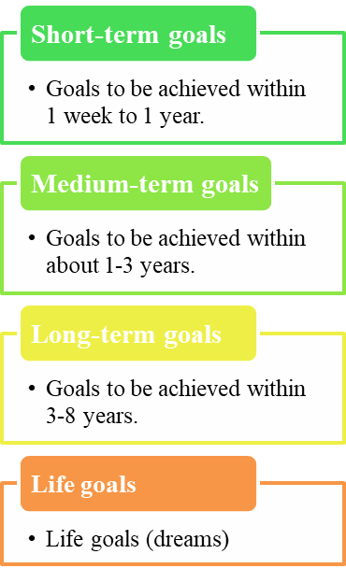

For example: Cut the nails for your dog.

For example: open a pet clinic.





**Fig. 4 Different types of goals**

**Worksheet 5: Principles of setting goals**

Everyone has his/her own dream. We should make early plans. Setting good plans is helpful for realising our dreams. Do you have a dream that you hope to achieve? Each of us can set a long-term goal based on our dreams, and then set a series of short-term goals accordingly. Bear in mind that the goals of different stages need to be related. In the end, a combination of the achieved small goals can lead us to the realisation of our big dreams!



**I want to start a business**

Chi Man wants to own a computer software development company. Below is Chi Man’s road towards realising his dream**.**

**Chi Man’s road towards realising his dream**

**Long-term goal: become a computer software engineer**

**Life goal (dream):**

**Own a computer software development company**

**Short-term goals**

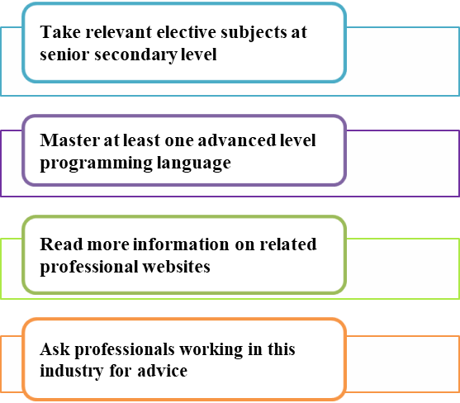

When we have set our goals, we must put our plans into action and should not give up halfway through the process. Meanwhile, effective time management is very important. Therefore, whenever we set a short-term goal, we must make a reasonable estimation of time required to accomplish it. The set goals are not unchangeable. Instead, we should adjust our goals in the light of changing situations. Taking the goals of Chi Man as an example, if he can’t take one of his favourite elective subjects at senior secondary level because his school does not offer it, he can change his short-term goal by enrolling a similar course in another educational institution. As long as we are moving towards the same direction, the specific steps to achieve our goals can be adjusted according to the actual environment. After achieving the short-term goals at one stage, we can set short-term goals for the next stage.

Short-term goals and long-term goals should be closely related. In addition, as we grow older, we gain more life experience and have a better understanding of ourselves and opportunities and challenges around us, we need to re-visit the 4 major elements of life planning (namely “Self-awareness”, “Awareness of the surroundings”, “Goal setting” and “Actions”) and then adjust our short-term goals and long-term goals.



**Know More**

Confucius once observed, “At 15, I set my heart upon learning. At 30, I become independent. At 40, I no longer get puzzled. At 50, I knew what the destiny is. At 60, I listen to people without interference. At 70, I can do what I want without breaking the rules.” His saying can be called a model of life planning.

Source: 呂雙波、田洪江（2016）, 《讀懂孔子》.



**A famous poet once said: You are the master of**yourdestiny and the navigator of your soul. **You can make your** life what you want it to be. Therefore, don’t underestimate the importance of setting goals. Set your goals right now, because your future is lying in front of you.

Source: 馬銀文, 吳學剛 (2017)《改變人生的99次關鍵抉擇：只有抉擇，人生才有主題；只有抉擇，人生的坎坷才會被踏平》.

**Activity 1: SMART goals**

The “**SMART principle**” was put forward by Peter Drucker, a Master of Management, in 1954. This is originally a set of methods of management by objectives to improve staff efficiency. But at the same time, it is also applicable to goal setting, which can make our goals more specific, detailed and practical. It helps us to set clear goals more effectively, know clearly our progress in achieving our goals and make our dreams practical.

State clearly **what you want to do**

(e.g. with the help of 5W1H Method – what, who, where, when, why and how)

Contents to be **related to goals**

Can be completed **within one’s capacity**

The standard to be reached are stated in **numbers**

(e.g. 10 minutes, 100 times)

Have clear **timelines for completion**

(e.g. days, weeks, months)

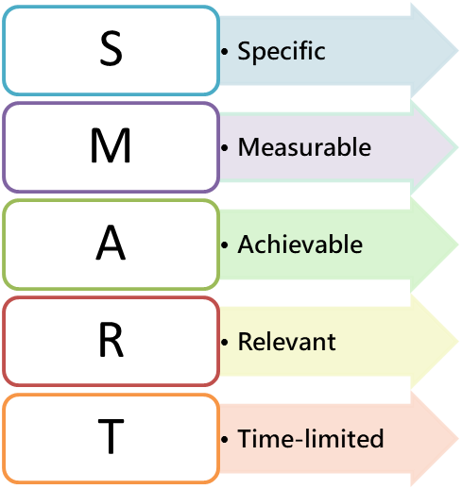

**Fig. 5 Setting SMART goals**

Example 1: **I wanted to know the style of traditional Beijing hutongs, so I finished reading the book “*My Memories of Old Beijing*” in two months.**

|  |  |  |  |  |
| --- | --- | --- | --- | --- |
| **Specific** | **Measurable** | **Achievable** | **Relevant** | **Time-limited** |
| to know the style of traditional Beijing hutongs | finished reading | I finished reading the book “*My Memories of Old Beijing*” in two months. | finished reading the book “*My Memories of Old Beijing*” | in two months |

Example 2: **I want to strengthen my limbs and increase my flexibility, so I jump rope 100 times every afternoon.**

|  |  |  |  |  |
| --- | --- | --- | --- | --- |
| **Specific** | **Measurable** | **Achievable** | **Relevant** | **Time-limited** |
| to strengthen my limbs and increase my flexibility | 100 times | jump rope 100 times every afternoon | jump rope | every afternoon |

Read the following goals carefully and put a tick “✓” beside the one which is “in line with” the SMART principle.

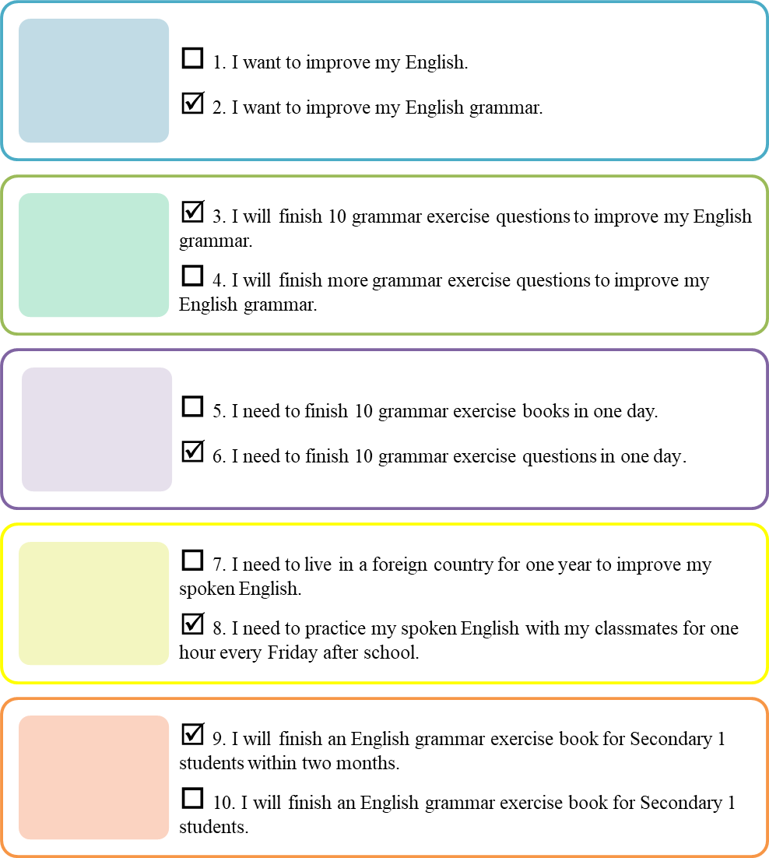

Excerpted and adapted from: 吳寶城 (2015), 《出路指南》第二冊.

**Activity 2: You SMART and I SMART**

Setting goals based on the SMART principle can not only help us realise our dreams but also help us check our progress so that we can clearly know how many things are unfinished and how far away we are from our dreams.

**Case 1**

Man Wai wants to improve her English grammar so as to represent the school in the English writing competition for all Secondary 1 students of Hong Kong next year.

Try to set short-term goals for Man Wai according to the SMART principle.

|  |  |  |
| --- | --- | --- |
| **Short-term goals of Man Wai:** | | *For example:*  *Represent the school in the English writing competition for all Secondary 1 students of Hong Kong next year.* |
| S | For example:   * Specific: State clearly what, who, when, where, why, how (at least one of them)   I want to (What) *improve English grammar so as to represent the school in the English writing competition for all Secondary 1 students of Hong Kong (When)next year.* | |
| M | I will finish *10 grammar exercise questions every day.*   * Measurable: The standard to be reached is stated in numbers | |
| A | *I am able to finish 10 grammar exercise questions every day.*   * Achievable: Can be completed within capacity | |
| R | *Grammar exercise is related to English grammar competence.*   * Relevant: Be relevant to goals | |
| T | *I will finish one after-class exercise book of English grammar for Secondary 1 students within 2 months.*   * Time-limited: Have clear timelines for completion | |

**Activity 3: Set your own goals**



**Plans**

This activity is for you to set your **SMART short-term goals and long-term goals** based on the **SMART principle** according to your aspiration. The contents of your goals are not limited. For example, you can have goals about academic achievement, relationship with parents, relationship with friends, living habits, etc. After writing down your goals, you shall invite a classmate sitting next to you to check and determine if your goals are in line with the **SMART principle**. While you are checking the goals of your classmate, you should not only refer to the SMART principle but also check whether his/her long-term and short-term goals are closely related. If his/her goals can’t totally meet the requirements of the SMART principle or the goals are not closely related, please ask him/her to write the goals again and you should check again afterwards.

**My aspiration:** *For example: A professional fiction writer*

* **Long-term goal:**

|  |
| --- |
| *For example: I hope that I can become a professional fiction writer* |
| *and publish two fiction books before I am 30 years old.* |

* 🞏 **S**
* 🞏 **M**
* 🞏 **A**
* 🞏 **R**
* 🞏 **T**

Are these two goals closely related?

□ Yes

□ No

* **Short-term goals** (one of them):

|  |
| --- |
| *For example: I will publish a Chinese article of about 300 words on* |
| *the Internet every two weeks to improve my writing ability within 6* |
| *months.* |

* 🞏 **S**
* 🞏 **M**
* 🞏 **A**
* 🞏 **R**
* 🞏 **T**



**Don’t forget**

Keep in mind the goals you set and strive to achieve them in the days to come!

**Worksheet 6: Taking action to**

The teacher encourages students to study Self-learning material: “Take action on our dreams!” by themselves.

**equip yourself**Secondary school students should equip themselves as soon as possible; develop interests and capacities; broaden horizons; and make plans for further studies and future employment, in order to move towards their dreams gradually.



**Tips for life planning**

1. Everyone is born with talents.
2. Knowledge is power and waiting is a waste of time.
3. Think outside the box, try to do everything well and learn from others’ experience.

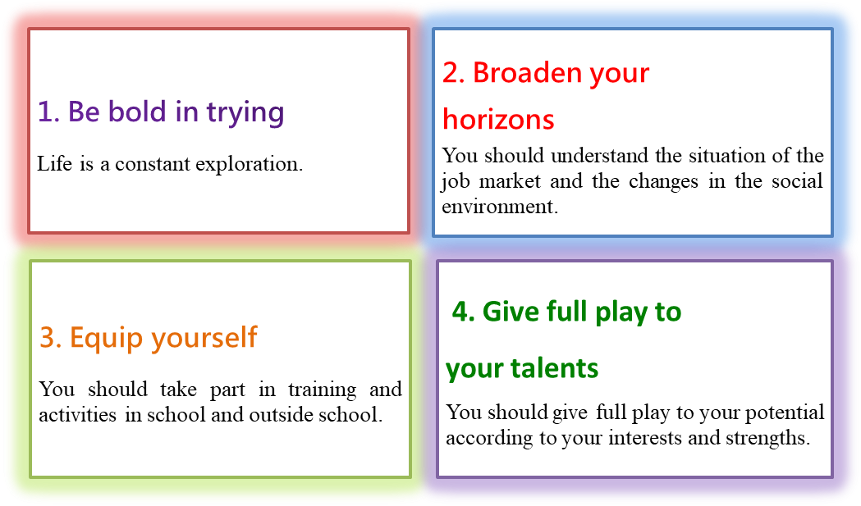

**Fig. 6 Tips for taking action on dreams**

**Actions and reflections**

Setting goals can provide us with a clear sense of direction. Young people should take early action to enhance their knowledge and skills. At the same time, at every stage, we should check our progress and achievements, reflect on the differences between plans and actual actions, make up for the deficiencies, reflect on current goals and set new goals for the next stage. The earlier we set our goals, the more time and opportunities we have to realise our dreams. Therefore, we should take action immediately.

**My life planning checklist**

This checklist will help you equip yourself, deploy actions, reflect on and adjust your goals on a regular basis after you have set your goals.



* Assess your characters, interests, abilities, potentials, values, etc.
* Understand your career orientation and career goals.
* Weigh up what subjects should be chosen based on employment market information.
* Understand the characteristics, nature and requirements of various industries (You can refer to

<https://lifeplanning.edb.gov.hk/en/career/career-information/index.html>).

* Design appropriate and practical learning plans
* Develop potential (such as Chinese, music, adventure training, etc).
* Get to know the local, mainland and overseas pathways for further studies and scholarship information (You can refer to https://lifeplanning.edb.gov.hk/en/study/index.html, or visit education exhibitions, go abroad for exchanges, participate in study tours, etc.)
* Participate in different volunteer services to know more about the needs of the society and job training programs.
* Review your progress and goals on a regular basis.
* Adjust your goals according to personal abilities and trends of the employment market.



**Conclusion**

Life planning is a long and continuous journey, which contains many unknown variables. As secondary school students, we need to explore ourselves as soon as possible, understand the trends in the external environment, plan our ways of life and take action. By setting short-term and long-term goals, we can move towards the same direction gradually; and adjust these goals in response to the rapid changes of society and the world so that we can realise our dreams and strive to live fulfilled lives and bring common good to the society.



**Life planning**



**Joyful Reading**

Appendix 2

**Learn from John Goddard to set goals and make plans**

John Goddard is a world-famous explorer. When he was 15 years old, he made a list, which was entitled “My Life List”, of the great things he wanted to do in his life, including exploring the Nile River, Amazon River and Congo River, learning to pilot airplanes, reading all of Shakespeare’s works, etc. He numbered every one of his dreams and there were 127 goals in total. 43 years later, after 18 adventures of narrow escapes and countless unimaginable difficulties, he achieved 106 goals and was honoured as the World Explorer.

Goddard said, “I have drawn up this blueprint to work for and I have a goal in my mind, so that I will feel that there is always something to do.” It can be seen that goals play a big role in motivating, maintaining and consolidating his enterprising spirit.

Source: mingyanjiaju.org (undated), Inspirational stories.

Reflective questions:

1. Has the character impressed you? Why?
2. What do you learn from the story of this character?
3. The character did not only strive to fulfil his own personal goals in life. He also contributed to the human society. Can you find out more about his contribution to society from reliable sources?

Everyone’s life is a story. From now on, set your goals and write your own story.



Self-learning materials

**Take action on our dreams!**

**Activity 1: Action plan**

Try to make an action plan according to your short-term goals in “Activity 3: Set your own goals” (Worksheet 5) and put it into practice. One week later, you will carry out Activity 2 to review the progress of your plan and your achievements. You should also reflect on the difference between your plan and the actual situation and what you learned from it.

Note: The goals in your action plan need to be short-term goals that can be achieved within one week.

|  |  |  |
| --- | --- | --- |
| Action start date: _________________ Completion date of the plan: _____________ | | |
|  | 1. My **short-term goal** is   *For example:*  *To participate in the school’s annual painting competition and my entry will be a magnificent landscape painting.* | |
|  | 1. **Actions** to take to achieve the goal (You can refer to the SMART principle to plan actions that are goal-related, specific and achievable.) *(You can write down more than one action.)*    1. *Searching for related painting skills.*    2. *Preparing related painting tools.*    3. *Choosing a painting site and searching for the transportation route and then going to the site with family on Saturday.* | |
|  | 1. Other things that I need to complete. (Things that are irrelevant but need to be done, for example, helping younger brothers or sisters review their lessons.) *(You can write down more than one thing.)*    1. *Completing homework.*    2. *Revising knowledge on textbooks.* | |
|  | 1. **Other things** that will **hinder** me from achieving my goals: (Things that are irrelevant and not necessary) *(You can write down more than one thing.)*    1. *Playing computer games for half an hour every night.*    2. *Playing basketball with friends 3 times every week.* | 1. **Approaches to problems:** (For example: reducing the time spent on playing computer games.)    1. *Playing 15 minutes less on computer games.*    2. *Playing basketball with friends only one time every week.* |
|  | 1. **Put the things to do in item 2 and item 3 in order.**   *Completing homework.*  *Revising knowledge on textbooks.*  *Searching for related painting skills.*  *Preparing related painting tools.*  *Choosing a painting site and searching for the transportation route and then going to the site with family on Saturday.* | |

**Activity 2: Review and reflection**

You need to invite your family or friends to take part in this activity (Take action on our dreams!). The details are as follows:

1. **Preparation:**

After you complete the action plan in Activity 1, you should give a copy of the action plan to your family or friends and ask them to observe how you put your plan into practice in the week that follows.



1. **Review and reflection** (after the action plan has been carried out)

Views of family or friends: Invite your family or friends who have taken part in this activity to review and reflect on your action plan with you, and then ask them to give advice, encouragement and suggestions for follow-up actions according to your progress and achievements in Table 1.

My reflection: Reflect on your performance in the past week by referring to the views of your family or friends and write down your reflection in relevant spaces in the table below.



**Table 1: Review and reflection**

|  |  |  |
| --- | --- | --- |
| **Actions** | **Views of family or friends\*** | **My reflection\*** |
| 1. **Progress of the plan**   (Is the progress ideal?) | □ Ideal  □ Generally ideal  □ Not ideal  Reasons for the above result:  _________________________  _________________________ | □ Ideal  □ Generally ideal  □ Not ideal  Reasons for the above result:  _________________________  _________________________ |
| 1. **Extent of completion of the plan**   (Is it completed? To what extent?) | □ Completed  □ _____ % completed  □Not completed  Reasons for the above result:  ________________________  _________________________ | □ Completed  □ _____ % completed  □ Not completed  Reasons for the above result: _________________________  _________________________ |
| 1. **Level of satisfaction with the achievements**\*\*   (Are the achievements satisfactory?) | □ Satisfactory  □ Not satisfactory, reasons: _________________________  _________________________ | □ Satisfactory  □ Not satisfactory, reasons: _________________________  _________________________ |
| 1. **Suggested follow-up actions** |  |  |
| 1. **Words of encouragement** |  |  |
| **Signature** |  |  |

*Please put a “✓” in the appropriate box and write down your opinions in the spaces.

**For example: Your short-term goal is to post an article online. A week later, an article is posted on time, but it is of poor quality. Then this is a not satisfactory achievement.

**References**

104測評銀行 (undated). Work values rating scale: Assessment structure and contents (《工作價值觀量表：測驗架構與內容》). <https://assessment.104.com.tw/paper/workvalue/cont.jsp>

people.cn (13 March 2013). Australia is looking for people to take the best job of the world again Eating at all the top restaurants (《澳洲又開招世界最好工作 吃遍高級飯店》).   
<http://mnc.people.com.cn/BIG5/n/2013/0313/c54816-20775403.html>

Sichuan Writers Association (1999).《建國50年四川文學作品選》。四川：四川文藝。

呂雙波、田洪江（2016）。《讀懂孔子》。台北：元華文創。

吳寶城（2015）。《出路指南》第二冊。香港：學友社。<http://www.student.hk/site/?q=system/files/pg2015_b2_part1.pdf>

明報升學網 (21 June 2018). Only by exploring actively can we make good life plans (《只有主動探索 才可做好生涯規劃》).

<https://jupas.mingpao.com/non_jupas/只有主動探索-才可做好生涯規劃/>

Education Bureau, the government of the Hong Kong Special Administrative Region (15 August 2019). Life Planning Information. <https://lifeplanning.edb.gov.hk/tc/index.html>

hket (12 January 2009). The Australian Great Barrier Reef is recruiting a caretaker with a monthly salary of HK$ 140000 (《澳洲大堡礁筍工 聘保育員月薪14萬》).

<https://paper.hket.com/article/1001629/澳洲大堡礁筍工%20聘保育員月薪14萬>

馬銀文、吳學剛（2017）。《改變人生的99次關鍵抉擇：只有抉擇，人生才有主題；只有抉擇，人生的坎坷才會被踏平》。台北：崧博。

陳澤義（2019）。《管理與人生》（第三版）。台灣：五南。

Hok Yau Club (1 July 2020). Life planning: Carry out your life plan and manage your life actively! (〈生涯規劃：《實行生涯規劃，主動經營人生！》〉). <http://student.hk/site/?q=article/680>

蘇楊、高鐵軍、‎高偉、段斌、‎劉積山、靳西、高國政、勾良圖（2015）。《卡耐基的人生哲學叢書》。中國：青蘋果數據中心。

Drucker, P. F. (2012). *The Practice of Management.* Oxford: Butterworth-Heinemann.

mingyanjiaju.org (undated). Inspirational stories (《勵志小故事》). <https://mingyanjiaju.org/lizhixiaogushi/>

Neary, S. & Johnson, C. (2016). *CPD for the career development professional: A handbook for enhancing practice*. Bath, UK: Trotman.

Universum (2022). *Hong Kong's Most Attractive Employers 2022*.

Weihrich, H. (1982). The TOWS Matrix - A tool for situational analysis. *Long Range Planning*, 15(2), 54 - 66. <https://www.sciencedirect.com/science/article/abs/pii/0024630182901200>

**(Blank Page)**

